Module 3 from Performance Consideration.

Q Explain any one memory design feature to improve performance of system in detail.
Q. Explain Hit rate and Miss Penalty.
Q. Explain Virtual Memory Organization
Q What is virtual Memory? How virtual address is translated to physical address.
Q. Explain Magnetic Disk Principles
Q. Explain Magnetic Tapes

Solved Problems:-

- A block set associative cache consists of a total of 64 blocks divided into 4 block sets. The MM contains 4096 blocks each containing 128 words.
- How many bits are there in MM address?
- How many bits are there in each of the TAG, SET & word fields

Solution:- Number of sets = 64/4 = 16
Set bits = 4(2⁴ = 16)
Number of words = 128
Word bits = 7 bits (2⁷ = 128)
MM capacity : 4096 x 128 (2¹² x 2⁷ = 2¹⁹)
- Number of bits in memory address = 19 bits
b)

8 | 4 | 7
TAG | SET | WORD
TAG bits = 19 – (7+4) |  |  |  | = 8 bits.

- A computer system has a MM capacity of a total of 1M 16 bits words. It also has a 4K words cache organized in the block set associative manner, with 4 blocks per set & 64 words per block. Calculate the number of bits in each of the TAG, SET & WORD fields of MM address format.

Solution: Capacity: 1M (2²⁰ = 1M)

Number of words per block = 64

Number of blocks in cache = 4k/64 = 64

Number of sets = 64/4 = 16

Set bits = 4 (2⁴ = 16)

Word bits = 6 bits (2⁶ = 64)

Tag bits = 20-(6+4) = 10 bits

MM address format: 10 tag bits, 6 word bits and 4 set bits.

5.6 PERFORMANCE CONSIDERATIONS
Q Explain any one memory design feature to improve performance of system in detail.

A key design objective of a computer system is to achieve the best possible performance at the lowest possible cost. Price/performance ratio is a common measure of success.

Performance of a processor depends on: How fast machine instructions can be brought into the processor for execution. How fast the instructions can be executed.

- Interleaving

Divides the memory system into a number of memory modules. Each module has its own address buffer register (ABR) and data buffer register (DBR). Arranges addressing so that successive words in the address space are placed in different modules. When requests for memory access involve consecutive addresses, the access will be to different modules.

Since parallel access to these modules is possible, the average rate of fetching words from the Main Memory can be increased.
Methods of address layout:

1)
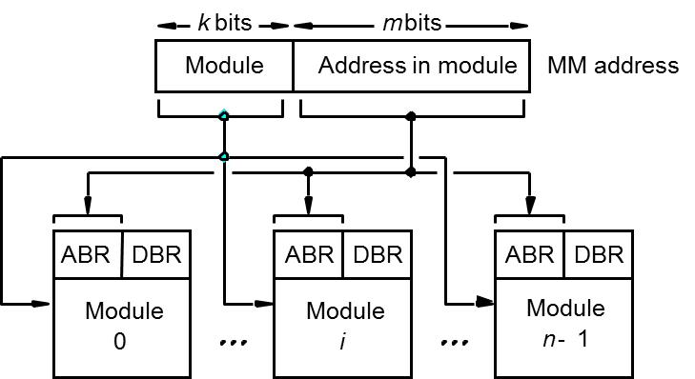

Consecutive words are placed in a module. High-order k bits of a memory address determine the module. Low-order m bits of a memory address determine the word within a module. When a block of words is transferred from main memory to cache, only one module is busy at a time.

2)
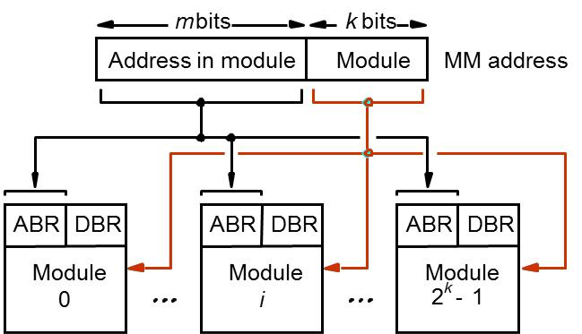

Consecutive words are located in consecutive modules. Consecutive addresses can be located in consecutive modules. While transferring a block of data, several memory modules can be kept busy at the same time.

Example: Transfer block of data from Main memory to cache when read miss occurs
- Cache of 8 words in each block.
- Single Memory Module
  - Send address to MM=1 Clock Cycle.
  - Read first word from MM(DRAM)=8 clock cycles
  - Subsequent words=4 Clock Cycles.
  - Send words to cache= 1Clock Cycle.
  - Time needed to load desired block into cache
  - 1+8+(7*4)+1=38 cycles.
- Four Interleaved Modules
  - Send address to all 4 Memory Modules=1 Clock Cycle.
  - All memory modules read one word into DDR=8 clock cycles
  - 4 words transferred to cache in next 4 clock cycles.
  - During this time all 4 modules access next 4 words.
  - Another 4 cycle to transfer data to cache
  - Time needed to load desired block into cache
  - 1+8+4+4=17 cycles.
Q. Explain Hit rate and Miss Penalty.
- Hit rate and miss penalty

- The number of hits stated as fraction of all attempted accesses is called the hit rate and the number of misses stated as a fraction of all attempted accesses is called the miss rate.

- The extra time needed to bring the desired information into cache is called as miss penalty.

- Hit rate can be improved by increasing block size, while keeping cache size constant

- Block sizes that are neither very small nor very large give best results.

- Miss penalty can be reduced if load-through approach is used when loading new blocks into cache.

- Avg access time experienced by processor is

tave = hC + (1-h)M

h- hitrate, M – miss penalty, C- time to access info from cache.

Example:
Assume that 30 percent of the instructions in a typical program perform a read/write operation, which means that there are 130 memory accesses for every 100 instructions executed.
h=0.95 for instructions, h=0.9 for data, 10 clock cycles for Memory Read Access.
C=1 clock cycle, M=17 clock cycles to load block into cache,
Time without cache / Time with cache
=130x10/ 100(0.95x1+0.05x17)+30(0.9x1+0.1x17)
The computer with the cache performs five times better

- Caches on the processor chips
In high performance processors 2 levels of caches are normally used.

Avg access time in a system with 2 levels of caches is

T ave = h1c1+(1-h1)h2c2+(1-h1)(1-h2)M

h1- hit rate of Cache 1, h2- hit rate of Cache 2, M – miss penalty, c1- time to access info from cache1, c2- time to access info from cache2.

Other Enhancments
- Write buffer

Write-through: Each write operation involves writing to the main memory. If the

processor has to wait for the write operation to be complete, it slows down the

processor. Processor does not depend on the results of the write operation. Write buffer

can be included for temporary storage of write requests. Processor places each write

request into the buffer and continues execution. If a subsequent Read request references

data which is still in the write buffer, then this data is referenced in the write buffer.

Write-back: Block is written back to the main memory when it is replaced. If the

processor waits for this write to complete, before reading the new block, it is slowed

down.Fast write buffer can hold the block to be written, and the new block can be read

first.

- Prefetching – Prefetch the data into the cache before they are needed.
- Methods for prefetching
- Software instructions- Avoid read miss
  - Programmer or compiler may add the instructions for preloading data before program starts executing.
  - Machine instructions may be added
- Hardware – Add circuit to discover pattern in memory references
- Lockup-Free cache
- Prefetch may interfere normal execution of instruction
- Processor is able to access the cache while a miss is being serviced.
- A cache that supports multiple outstanding misses is called lockup-free. A circuit may keep track of all outstanding misses using registers that hold pertinent information about these misses
5.7 Virtual Memory

Q. Explain Virtual Memory Organization
An important challenge in the design of a computer system is to provide a large, fast memory system at an affordable cost. Cache memories were developed to increase the effective speed and Virtual the effective size of the memory system.

The addressable memory space depends on the number of address bits in a computer. For example, if a computer issues 32-bit addresses, the addressable memory space is 4G bytes. Physical main memory in a computer is generally not as large as the entire possible addressable space. Physical memory typically ranges from a few hundred megabytes to 1G bytes. Large programs that cannot fit completely into the main memory have their parts stored on secondary storage devices such as magnetic disks. Pieces of programs must be transferred to the main memory from secondary storage before they can be executed.

Techniques that automatically move program and data between main memory and secondary storage when they are required for execution are called virtual-memory techniques.
Processor issues binary addresses for instructions and data. These binary addresses are called logical or virtual addresses.
Virtual addresses are translated into physical addresses by a combination of hardware and software subsystems.
If virtual address refers to a part of the program that is currently in the main memory, it is accessed immediately. If the address refers to a part of the program that is not currently in the main memory, it is first transferred to the main memory before it can be used.
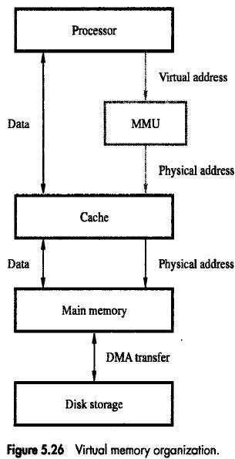

Memory management unit (MMU) translates virtual addresses into physical addresses. If the desired data or instructions are not in the main memory, they must be transferred from secondary storage to the main memory. MMU causes the operating system to bring the data from the secondary storage into the main memory.

Address Translation
Q What is virtual Memory? How virtual address is translated to physical address.

Assume that program and data are composed of fixed-length units called pages. A page consists of a block of words that occupy contiguous locations in the main memory. Page is a basic unit of information that is transferred between secondary storage and main memory. Size of a page commonly ranges from 2K to 16K bytes. Pages should not be too small, because the access time of a secondary storage device is much larger than the main memory. Pages should not be too large, else a large portion of the page may not be used, and it will occupy valuable space in the main memory.

Concepts of virtual memory are similar to the concepts of cache memory.

Cache memory: Introduced to bridge the speed gap between the processor and the main memory. Implemented in hardware.

Virtual memory: Introduced to bridge the speed gap between the main memory and secondary storage. Implemented in part by software.

Each virtual or logical address generated by a processor is interpreted as a virtual page number (high-order bits) plus an offset (low-order bits) that specifies the location of a particular byte within that page. Information about the main memory location of each page is kept in the page table. Main memory address where the page is stored. Current status of the page. Area of the main memory that can hold a page is called as page frame. Starting address of the page table is kept in a page table base register.

Virtual page number generated by the processor is added to the contents of the page table base register. This provides the address of the corresponding entry in the page table. The contents of this location in the page table give the starting address of the page if the page is currently in the main memory.
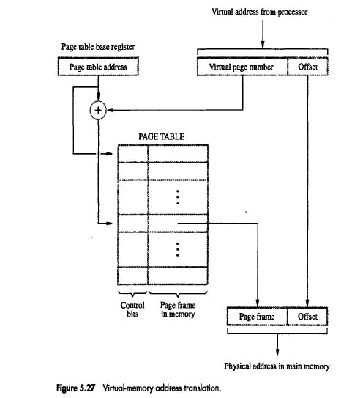

Page table entry for a page also includes some control bits which describe the status of the page while it is in the main memory. One bit indicates the validity of the page. Indicates whether the page is actually loaded into the main memory. Allows the operating system to invalidate the page without actually removing it. One bit indicates whether the page has been modified during its residency in the main memory. This bit determines whether the page should be written back to the disk when it is removed from the main memory. Similar to the dirty or modified bit in case of cache memory. Other control bits for various other types of restrictions that may be imposed. For example, a program may only have read permission for a page, but not write or modify permissions.

The page table is used by the MMU for every read and write access to the memory. Ideal location for the page table is within the MMU. Page table is quite large. MMU is implemented as part of the processor chip. Impossible to include a complete page table on the chip. Page table is kept in the main memory. A copy of a small portion of the page table can

be accommodated within the MMU. Portion consists of page table entries that correspond to the most recently accessed pages.
Q. Explain Translation Look Aside Buffer(TLB)

A small cache called as Translation Lookaside Buffer (TLB) is included in the MMU. TLB holds page table entries of the most recently accessed pages. The cache memory holds most recently accessed blocks from the main memory. Operation of the TLB and page table in the main memory is similar to the operation of the cache and main memory. Page table entry for a page includes: Address of the page frame where the page resides in the main memory. Some control bits. In addition to the above for each page, TLB must hold the virtual page number for each page.
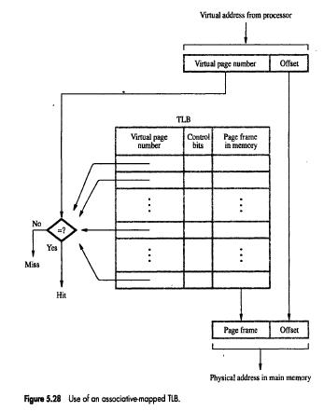

Associative-mapped TLB: High-order bits of the virtual address generated by the processor select the virtual page. These bits are compared to the virtual page numbers in the TLB. If there is a match, a hit occurs and the corresponding address of the page frame is read. If there is no match, a miss occurs and the page table within the main memory must be consulted. Set-associative mapped TLBs are found in commercial processors.

If a program generates an access to a page that is not in the main memory a page fault is said to occur. Whole page must be brought into the main memory from the disk, before the execution can proceed. Upon detecting a page fault by the MMU, following actions occur: MMU asks the operating system to intervene by raising an exception. Processing of the active task which caused the page fault is interrupted. Control is transferred to the operating system. Operating system copies the requested page from secondary storage to the main memory. Once the page is copied, control is returned to the task which was interrupted.

5.8 Secondary Storage

Q. Explain Magnetic Disk Principles

- Magnetic Disk Drives:

Consists of one or more disks called as platters mounted on a common spindle in a rotary drive.
Thin magnetic film is deposited on both sides.
Disks system has 3 main parts:
- Disks: Assembly of disk platters called as disks.
- Disk Drive: Electromechanical mechanism that spins the disks and moves R/W head .
- Disk Controller: Electronic circuitry that controls the operation of system. Implemented as separate module.
Disks rotate at uniform speed 10,000 RPM
Disk read/write heads
- Movable part of system and move above the disk platter .
- One R/W head for each platter. All heads mounted on an arm.
- Each head consists of magnetic yoke and magnetizing coil.
- It transforms the platter's magnetic field into electrical current (read the disk) or, vice versa, transform electrical current into magnetic field (write the disk)
- Digital information stored on magnetic film by applying current pulse of suitable polarity to magnetizing coil.
- This causes magnetization of film in area only under R/W head.
- Binary 0 and 1 are represented by two opposite states of magnetization.
- Voltage induced in head only at 0 to 1 and 1 to 0 transition in bit stream.
- Long string of 0’s and 1’s causes an induced voltage only at beginning and end of string.
- Phase Encoding/ Manchester Encoding: Change in magnetization occurs for each data bit at the midpoint of each bit period.
- Disadvantage: Poor bit storage density. Space required to store each bit is large enough to show two transition..
- To store high bit density and reliable data R/W head are at less distance from moving disks(0.3nonometer).
- Winchester Technology: Disks and R/W heads placed in sealed air filtered enclosure.
- Advantage: Avoid dust and more densely data can be packed along track.

Data organization on the Disk:- The drive needs to know where the data to be accessed is located on the disk. In order to provide that location information, data is organized on the disk platters by tracks and sectors.
Fig below shows simplified view of the organization of tracks and sectors on a disk.
The fig. shows a disk with 1024 tracks, each of which has 64 sectors. The head can determine which track it is on by counting tracks from a known location and sector identities are encoded in a header written on the disk at the front of each sector.
The number of bytes per sector is fixed for a given disk drive, varying in size from 512 bytes to 2KB.
All tracks with the same number, but as different surfaces, form a cylinder. The information is recorded on the disk surface 1 bit at a time by magnetizing a small area on the track with the write head. That bit is detected by sending the direction of that magnetization as the magnetized area passes under the read head as shown in fig below.
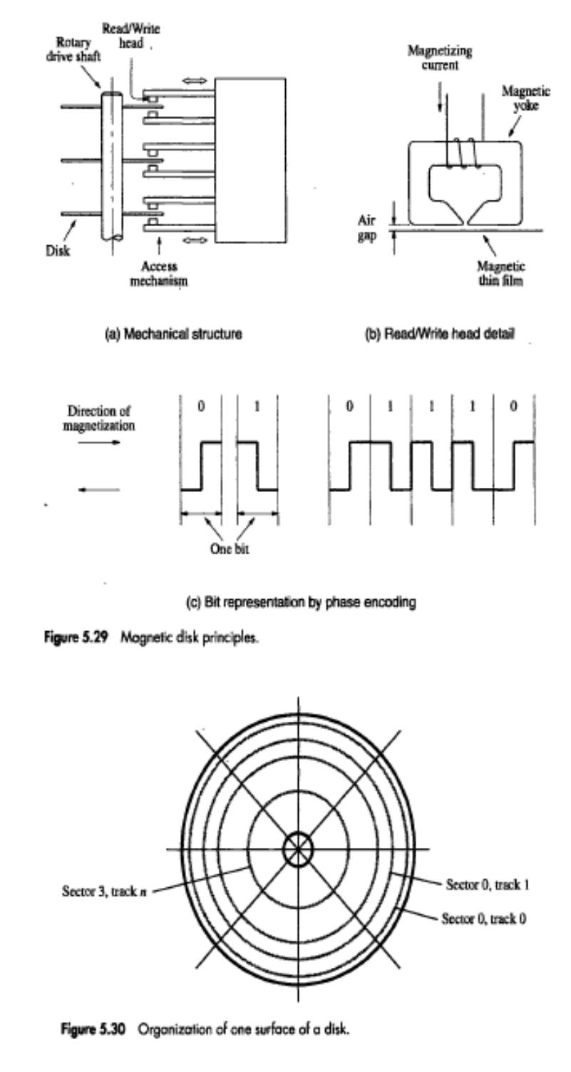
The header usually contains both synchronization and location information.

Disk Drive Dynamic Properties: -

Dynamic properties are those that deal with the access time for the reading and writing of data.. There are several measures of data access times.

- Seek time: - Is the average time required to move the read/write head to the desired track. Actual seek time which depend on where the head is when the request is received and how far it has to travel, but since there is no way to know what these values will be when an access request is made, the average figure is used. It will depend on the physical size of the drive components and how fast the heads can be accelerated and decelerated. Seek times are generally in the range of 8-20 m sec and have not changed much in recent years.

- Track to track access time: - Is the time required to move the head from one track to adjoining one. This time is in the range of 1-2 m sec.

- Rotational latency: - Is the average time required for the needed sector to pass under head once the head has been positioned once at the correct track. Since on the average the desired sector will be half way around the track from where the head is when the head first arrives at the track, rotational latency is taken to be ½ the rotation time. Current rotation speeds are from 3600 to 7200 rpm, which yield rotational latencies in the 4-8 ms range.

- Average Access time:- Is equal to seek time plus rotational latency.

- Burst rate: - Is the maximum rate at which the drive produces or accepts data once the head reaches the desired sector, It is equal to the rate at which data bits stream by the head, provided that the rest of the system can produce or accept data at that rate

Burst rate (byte/sec) = rows/sec * sector/row * bytes/sector

- Sustained data rate: - Is the rate at which data can be accessed over a sustained period of time.
Disk Controller
Provides interface between disk drive and bus
It can be used to control more than one disk.
It contains many registers same as I/O interface for communication with operating system.
OS initiates Read/ write request which loads controller registers with necessary addressing and control information as
Main Memory Address-Address of first location in main memory for transfer.
Disk Address-The location of sector containing beginning of desired block of words.
Word Count-Number of words in block to be transferred.
Use DMA for data transfer between Disk and Main Memory.

Processor
Main memory
System bus
Disk controller
Disk drive
Disk drive

Q. Explain Magnetic Tapes
Refer text book for diagram
- Suitable for off line storage of large amount of data.
- Used for hard disk backup.
- Same as magnetic disk.
- Magnetic film is deposited on a very thin 0.5-0.25 inch wide plastic tape.
- 7 or 9 bits are recorded in parallel using separate R/W head for each bit.
- Data organized as record separated by gaps. Tape motion is stopped when record gap Is underneath head and allow tape to attain normal speed before the beginning of next record. Gaps identified by area with no change in magnetization.
- Large amounts of data organized as a group of related records called file.
- Beginning of file identified by file mark. It is a special single or multiple character record.
- First record after file mark is called header or identifier for the file.
- Control commands executed on magnetic tape are
  - Rewind Tape
  - Rewind and unload tape
  - Erase Tape
  - Write Tape Mark ( Beginning of tape)
  - Forward space one record
  - Backspace one record
  - Forward space one file
  - Backspace one file.
- Methods of formatting and using tape
  - Records of variable length:
  - Efficient use of tape
  - But does not permit updating or overwriting of records.
  - Fixed length records
  - Allow record updating.

Source
No reflection
Reflection
File
7 or 9
gap
gap
File gap
Record
Record
Record
Record
bits
•
•
•
•
•
•
•
•

Optical Disks
Refer to text book Fig5.32 for clear diagram

Compact Disk (CD) Technology:- The optical technology that is used for CD system is based on laser light source. A laser beam is directed onto the surface of the spinning disk. Physical indentations in the surface are arranged along the tracks of the disk. They reflect the focused beam towards a photo detector, which detects the stored binary patterns.
The laser emits a coherent light beam that is sharply focused on the surface of the disk. Coherent light consists of Synchronized waves that have the same wavelength. If a coherent light beam is combined with another beam of the same kind, and the two beams are in phase, then the result will be brighter beam. But, if a photo detector is used to detect the beams, it will detect a bright spot in the first case and a dark spot in the second case. A cross section of a small portion of a CD shown in fig. below. The bottom layer is Polycarbonate plastic, which functions as a clear glass base. The surface of this plastic is Programmed to store data by indenting it with pits. The unindented parts are called lands. A thin layer of reflecting aluminium material is placed on top of a programmed disk. The aluminium is then covered by a protective acrylic. Finally the topmost layer is deposited and stamped with a label.

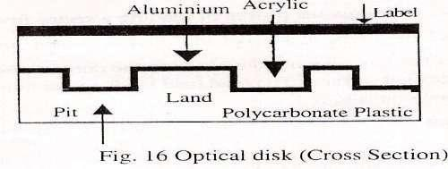
Source
Source
No reflection
Reflection
Land
The laser source and the Photo detector are positioned below the polycarbonate plastic. The emitted bean travels through this plastic, reflects off the aluminium layer and travels back toward photo detector.
As shown in figure 5.32b as light reflects solly from pit or land the detector will see reflected beam as bright spot. ( recognised as 0)
When a beam moves through the edge where pit changes to land and vice versa the reflected beam is a dark spot( recognised as 1)
The reflected wave from pit is 180 deg out of phase with wave reflected from land cancelling each other.
Pits are arranged on tracks . CD is 120mm in diameter. 15mm hole in center.
Data stored from area 25mm radius to 58 mm radius.
Space between each tarck 1.6 microns.Pits are 0.5 micron wide and 0.8 to 3 micron long.
There are 15,000 tracks on disk
Some important optical disks are listed below
- CD-ROM- Data organized as tracks and sectors.
- Prepare master disk using high power laser to burn holes for required pits.
- Prepare mold from master disk that has bumps in places of holes.
- Inject molten polycarbonate plastic into mold to make CD.
- Mode 1 Format- 2352 bytes sectors.
- 16 bytes header – synchronization- beginning of sector
- Addressing field- sector address
- 2048 bytes data.
- At the end 288 bytes for Error correcting scheme.
- data transfer rate < 6 Megabytes/s
- Seek time in several milliseconds
- CD_ROM inferior to Magnetic Disks
- Advantages: Small, Low cost, ease in handling
- CD-Re Writable
- Most flexible and written multiple times.
- Use an alloy of silver, indium, antimony and tellurium.
- CD-RW drives uses 3 different laser powers:
- Highest power used to record pits.
- Medium power to erase contents.
- Low power to read stored information.
- R/W CD up to 1000 times.
- DVD technology (Digital Versatile disk)

- Physical size same as CD 120mm diameter and 1.2mm thickness.
- Storage capacity is made larger by several design changes:
- Red light laser of wavelength 635mm is used instead of infrared laser light with wavelength of 780mm.
- Pits are smaller of 0.4 micron.
- Tracks are placed closer at distance of 0.74 micron.
- Hence DVD capacity is 4.7Gbytes.

